===================================================================

41-V2
Handbook of student
Maj/2020

HANDBOOK OF STUDENT

............................................................................
PRISTINA, May 2020

Dear students,
UBT has been founded on 19th of October 2004, after being licensing from the Ministry of Education, Science and Technology. UBT was established as a result of a successful work of the Institute for Enterprise Management and Engineering - IEME, which now operates under UBT.
UBT is a modern institution of higher education, which has been consistently increasing the number of students, professors and administrative staff on annual basis. As a matter of fact, the high scale of institutional organization and consolidation provides excellent opportunity for bearing quality, modern studies and in line with the development trends of higher education in developed countries.
Due to the fact, organization and studies in UBT differs from the academic structure and the teaching mode from other universities that operate today in Kosovo, we consider it necessary to outline and pay attention to this handbook for easier orientation and management of the situations and requirements of students in time and quality. Nevertheless, the beginnings of an institution's work can be followed by difficulties and obstacles of various natures. As a result, this may lead to it may happen that the level of information and services is not of the desired quality.
Indeed, to meet your demands in a qualitative and cultured manner, we ask you to pay attention to the following instructions that derive from this manual.
Thank you in advance for your support and cooperation!
UBT Team

1. WHICH IS THE ACADEMIC STUDY STRUCTURE?
The University offers two-tier study programs according to ISCED:
-a. Basic studies - bachelor and master
- Basic studies represent the first stage (third level) of tertiary education, which takes place in two cycles (bachelor and master) and does not directly lead to a qualification for advanced (advanced).
- Advanced (advanced) studies represent the second stage (third level) of tertiary education, which leads to a qualification for advanced (advanced) research.
- Studies in the first stage of the third level (level 6) are carried out mainly in English and in Albanian.
2. WHICH IS THE STRUCTURE OF STUDY PROGRAMS?
Due to the significant importance of this study program, it is carried out a multifaceted recognition and assuring of the conveyance of knowledge at the university level. Consequently, programs are harmonized and standardized, both by content and by the number of credits per semester in the relevant subject or field.
The study programs leading to the diploma / certificate in the faculty and the respective profile are modular, expressed through the collection of credits under the European Credit Transfer System (ECTS) and the American System HRS.
The content of this program content is established and drafted within the subject curricula of the faculty and the respective management. (Notice: see subject curricula by faculties and respective directions).
Basic subjects (bachelor), for six semesters, are primarily divided into:
- general pre-core subjects;
- core/essential subject’s mandatory for all students;
- the main mandatory subjects for the chosen course in which the student (major) and
- elective subjects, which the student can choose from different fields (elective).
Each subject, according to the syllabus, is planned to be developed in relevance with the modules in the respective semesters and has a certain number of classes divided per week. The semester usually begins on October 1 of the academic year and lasts 16 weeks of regular work. (Notice: see Regulation on the organization of the teaching process).
The number of classes for the subject is converted into a number of credits by two systems, the European and American systems.
To gain a bachelor's degree, you need at least 124 hours in respect to the American system (HRS) or 180 credits according to the European system (ECTS). In this number of credits are also calculated credits obtained from seminars, projects and diploma work or thesis.
In order to gain a Master's Degree in Master's Degree, the curriculum must at least be equivalent to 300 ECTS credits, including the credits earned from basic bachelor programs.
To earn a six (8) doctorate degree, the curriculum must at least have the equivalent of 480 ECTS credits, including credits earned from level 7 studies.
It is a minimum requirement that, for all qualifications in bachelor studies, 1/3 of total credits be earned from UBT studies.
3. WHICH ARE THE RIGHT STEPS FOR A SUCCESSFUL IN LEGISLATION?
Before starting the lectures, it is necessary to;
- Send all the valid documents required by the competition to fill out your personal file and other administrative and financial services to prepare the study contract;
- Carefully read the regulations of the university, announced on the ground floor of the institution;
- Check and sign the study contract with the university;
- Search for in-depth information the Student Service Office for the calendar year of the academic year, including official holidays.
- Ask the Student Service Office for the lesson schedule and determine which learning rooms will develop the learning process;
- Receive the necessary information for the respective semester subjects, at the Student Service Office or in the respective department responsible for advertising;
- Provide and assure the necessary materials for teaching (textbooks, dispensaries, complementary literature, internet access, etc.) according to relevant subjects and in collaboration with the University Library;
- Check the results of the exams and verify with the Student Service Office, the fulfillment of the conditions to continue the studies in the following academic year (non-start students).
The beginning of lectures;
- The lectures are held by the course professor, who also leads the respective subject, in close cooperation with the assistant;
- Lectures last for 45 minutes. A lecture, usually, takes place within two hours of learning, that is, takes place within 90 minutes and then, if the lesson has 4 hours of instruction, it follows a break of 30 minutes and continues with the other two hours of total 90 minutes;
- The professors are required to provide an explanation and closely elaborate the course program, including those elements such as; purpose, objectives, main content, reference literature and assessment method;
- The students enjoy the right to ask the teacher for clarification of the assessment method, the number and types of examinations, the criteria and the method of evaluation, and the criteria and the way of obtaining credits for each subject of the semester;
- Ask the teacher for clarification by arranging certain consultations;
During the learning process;
- Take an active part in the lectures and become part of the process;
- Ask questions about things that are not clear and ask for clarification from the subject teacher;
- By your willingness and commitment to study hard, you will force the teacher to put a lot of efforts to maximize the entire elements required for a teaching process;
- It is not necessary to pay much attention and spend much time on formal matters, but seek, insist, and dedicate yourself to the content and quality of your studies;
- Ask the Student Service Office to meet the hygienic-sanitary conditions, technical and didactic conditions in the classrooms where the lectures are held and in the premises where you are taught, if they are not at the proper level.
- Take brief notes during the lectures and evaluate in a reasoned and objective manner each teacher's and assistant's work;
- Evaluate your ratings in the special box at the reception and we guarantee you anonymity of your assessment.
- An objective assessment not only for teachers, but also for all other UBT services, will help us take the necessary measures to improve the overall quality of our services.
It is of crucial importance to keep your lectures right, because your attendance at the lectures increases the ability and quality of the studies, but even though your presence in the lectures will be assessed by the teacher in the final grade of the relevant subject at a certain percentage for which he should notify you at the beginning of the lecture;
The teacher will keep notes of regarding the of student attendance in lectures and if the student is absent in 25 percent of the lectures, he risks losing the status of the regular student;
In cases of whatsoever problems and obstacles concerned with learning, contact to the coordinator of the respective program, the names of each of them will be posted on the notice board. If he is not capable of providing a solution to the problem please, ask for a meeting with the President of the University or with the person he authorizes to cope with the respective concerning issue.

WHICH ARE THE METHODS OF CARYING OUT THE EVALUATION SYSTEM?
The scale of student achievement, which comes as a result of evaluation, is quantified with numbers or marks comprehensible and equivalent to the degree of student achievement gained. The decision regarding the degree of student achievement and assessment is made by the professor of respective subject independently and in compliance with the criteria and professional evaluation principles.
The general criteria for the final evaluation, with the exception of the course curriculum, are:
a. Regular participation in lectures
b. Seminar works;
c. Mid-term Exams;
c. Results achieved in the final Exam;

For specific courses and subjects, the subject professor, in accordance with the dean of the faculty concerned, applies special criteria for student assessment, which should be made transparent to the students before the beginning of the learning process.
The assessment, aims to reveal and determine the most accurate degree of student achievement. It is primarily written in percentage, which is then converted in the equivalent to the letter indicated in the corresponding number.
Each grade should be equivalent to the standards of achievement as outlined in the table below, in relevance with the European Academic Assessment System.
Grade | Letter | % | Description
10  9  8  7  6  5*  5 | A  B  C  D  E  F  F | 90.00-100  80.00-89.99  70.00-79.99  60.00-69.99  50.00-59.99  30.00-49.99  0.00-30.00 | Excellent – proficient knowledge, only with some minor mistakes  Very good –beyond the medium standards, but with some mistakes  good – there have been achieved good results, but the general performance still needs improvement  satisfactory- good, with many mistakes  adequate – the results meet the minimal requirements  poor- it’s required extra effort from the student to earn the minimal credits  poor – the student is required to put on a lot o efforts to earn the minimal credits

5. HOW IT IS REALIZED THE PREPARATION AND OVERALL ADMINISTRATION OF THE EXAM?
Since the beginning of the academic year, the course professor decides on the types of measuring instruments and the assessment of the degree of student achievement in the subject matter.
The course professor informs the students about the types of assessment that are applied to measure the degree of student achievement in the subject as well as the types of examinations.
The course professor is obliged during the semester to evaluate the student's knowledge of the given teaching units and to follow his / her progress in the studies. The teacher is obliged to carry out the whole range of all professional and academic measures to help the student achieve the maximum possible number of studies when there is a will of the student.
The course professor is obliged to lead students to get to know about the percentage of the calculated percentage of each semester exam, within the general grade of the subject.
The final exam is organized to assess the student's achievement rate in all subject areas at the end of the respective semester.
The final exam is organized in three regular terms:
- February term;
- June term;
- September term;
In case of failure in the first term the student has the opportunity to be tested in two other terms. The student must be given sufficient time to complete the exam, at least two weeks from the date of completion of the module or from the date of announcement of the results.
The student is not permitted to attend the lectures and the teaching process, during the next semester in those subjects that ask for maximal achievements of previous semester subjects. Also, the student can take the exam in all those subjects of the respective level of education but are not subject to the contents of the other subjects.
Basically, the final exam score should be no more than 50% of the student's overall grade, except for specific subjects and when the University Senate decides takes specific measures.
Procedures
- The UBT authorities are obliged to announce the exam schedule for the entire academic year at the beginning of each academic year in the notice board. For the term of the exam, students are also informed via e-mail.
- In case of changing the exam schedule, this ought to be done with the permission of the rector or his authorized person, only in special cases. As far as this issue is concerned, students must be informed at least 5 days prior to the exam date announced in the table above.
- The student is obliged to submit the exams online through the electronic system (SMIS)
- The student who did not manage to submit the exam within the prescribed deadline, advertised on the notice board, with which students are also informed by electronic mail, cannot take the exam in the subject and within the respective deadline.
- To submit an examination, he / she must have preliminarily fulfilled the financial obligations to UBT in respect to the signed contract for study.
- The course professor is obliged to prepare a test (examination assignments) for each exam period, which provides a real and unpredictable assessment of student knowledge. This is the reason why, the tests must not be identical to any of the tests of the previous terms.
- The professor bears responsibility and is obliged to obtain at least three days prior to the examination, at the relevant UBT service, the nominal list of the students presented for the exam (exam record), which he / she must complete and return with the exam material in the relevant UBT service, upon completion of the exam.
- In cases when the course professor is facing difficulties or is unable to well-administer the exam (this is mainly for external professors), he is obliged to send the test (exam duties) to the responsible person at least three days before the exam date UBT. Due to the fact, UBT can make the necessary technical preparation of the exam and its good administration.
Administration
- UBT is obliged to create physical and psychological facilities for the examination process, so that the student's knowledge can be expressed realistically, without hampering, without interruption and inadmissible aid, on the one hand, and that knowledge can be assessed realistically by the professor, on the other hand.
- The UBT's administration, taking into account the number of students submitted for the exam, makes multiplication and strict secrecy of the test secrecy.
- In the absence of the professor of the subject, on the day of the exam, the relevant UBT service is obliged to professionally administer the exam process until the exam materials are passed to the respective professor, before for his obligations for the return report of the exam results held.
- In the absence of the respective professor or the subject assistant, the exam administration is made by the person appointed by the Rector (University President) or Vice Rector for Academic Affairs. In the absence of a rector (presidential) or a Vice-Rector for academic matters, the Examiner is appointed by the Secretary of the University.
- The test administrator has all the powers of exam administration, keeping the evidence (record) of the student's participation in the exam from the list of students who have submitted the exam, placement of students in such a way as to avoid copying between prohibiting the use of materials and teaching materials related to the subject and the examination and prohibition of mobile phones.
- When the substitute professor cannot appear to participate in the exam, the test administrator is obliged to pass on the record of taking the exam along with the tests.
- A student, who delays the exam, at the time, may be allowed to pass the exam only with the consent of the teacher or test administrator.
- The exam lasts according to the time given by the subject professor, but not more than 120 minutes or two full hours.
Results
- The professor of the respective subject is obliged to submit the return report and the test together with the results of the exam, expressed in percentages, at the relevant UBT service at least 14 days from the date of the exam.
- If the professor has not been present at the exam on the day of the exam, he / she is obliged to submit the return report and the tests together with the exam results to the respective service, at least 14 days from the date of the exam materials of UBT.
- In addition to the respective exam materials, the professor is obliged to submit the record of the exam results to the person in charge of the UBT who is archived in the UBT archive, and the test results are posted on the advertisement table and the same are registered in each student's computer files separately.
- The student has the right to have a look at his or her test in the presence of a subject professor, assistant or officer responsible for student affairs. The student is not entitled to have the original test but only his copy available.
- If the student is not satisfied with the results, he / she has the right to object to the subject professor and, in the worst case, to the Dean of the Faculty or the Learning Coordinator.
- In cases when the student is dissatisfied with the assessment of the exam, he or she may, within 48 hours after the announcement of the result, request a commission examination.
- The Dean of the faculty or Rector is obliged within 48 hours to form the respective commission for re-examining the student.
- A student who is not able to pass the exam in the relevant subject in the first term of the exam, he / she may test for the second time in the regular exam period. If the student couldn’t manage to pass the exam even after the second attempt he / she is enjoys the right to ask for the commission to be examined in the third term.

Nr. | The limit of students number who shall submit the exam | Calendar days for announcement of results
1 | 1 – 50 | 7
2 | 51 – 100 | 10
3 | 101 – 150 | 15
4 | 151 – 200 | 20
5 | 200 + | 30

- At the request of the student, the lecturer is obliged to give him / her a written assessment of the exam.
- The oral exam and the practical exam are public and are held in the presence of at least one other academic person from UBT.
- The lecturer is obliged, according to the above-mentioned deadline, to place the grades in SMIS, to take care of the accuracy of the data in the system, as well as within the deadlines defined above (48 hours after the announcement of the final results), submit 3 original copies to the respective faculty, as well as submit a copy of the exam to assess the interrelation of the expected questions and results.
- The Dean, after verification by the system (SMIS), signs the acceptance of the minutes of the results, after verifying the accuracy of filling out the form by the lecturer for the appropriate subject, time limits or other elements of regularity of the academic process and in this case the exam.
- Without the complete completion of the record of grades in the system, it is considered that the subject has not yet been fully realized / completed.
- Exam results are distributed, according to this destination:
  - One (1) original copy remains in the faculty archive;
  - One (1) original copy remains with the professor of the subject;
  - One (1) original copy is submitted to the student archiving service.
- All these actions are done within a day with a cover letter, through internal protocol.

Objection of grade

- The teacher must justify to the student the final grade.
- A student who has been negatively assessed on the exam or is dissatisfied with the assessment enjoys the right to file a counterclaim. The objection is submitted to the head of the respective Program within two days (48 hours) after the notification and / or publication of the grade. The objection must be well reasoned.
- The objection is also enabled in electronic form, through SIMS, in which case the Dean or the person in charge of the program must approve it in the electronic system.
- If the objection in the grade is grounded and the relevant professor does not approve the objection, then the Dean creates a commission. The Dean of the Faculty will approve the decision allowing the re-examination, appointing the Evaluation Commission and setting the time for the re-examination.
- The Evaluation Commission consists of: The Chairman and two (2) members, one of whom must be from the narrow field. The subject teacher, who is attacked with objection, cannot be the chairman of the Evaluation Commission.
- Further submission of the objection is not allowed against the evaluation of the Evaluation Commission for repeated examination.

Repetition the exam before the Commission

- If the student opposes the evaluation of the Exam Results, after consulting with the lecturer, if he thinks that there is a subjective evaluation and, based on the factual aspect presented in the objection, then the Faculty has the opportunity to decide on the formation of the Evaluation / Reassessment Commission.
- The re-examination is organized no later than three (3) days from the date of the assessment of the grounded objection.
- The written exam or part of the written exam is not repeated before the Evaluation Commission, but it is again reviewed, checked and evaluated.
- Based on the grades proposed by all members of the Evaluation Commission, the Chairman of the Evaluation Commission closes the final grade and, if the grade is positive, the Chairperson of the Commission records the grade in the appropriate document. The final grade cannot be positive if two (2) members of the Evaluation Commission have proposed a negative grade.
- The decision of the Evaluation Commission cannot be further challenged.

6. Which is the core function of the Student Service Office?

6.1 Which is the purpose of getting into touch with the Student Service Office?

This office provides you with the following services;

- Submission of the application for registration;
- Submission of documentation for filling in the personal file;
- Signing the contract for study;
- Submission of a request for receipt of a certificate as a regular student of UBT;
- Taking authorization that you are a regular student of UBT;
- To provide information regarding the lesson schedule;
- To provide information on the eventual change of class schedule;
- To provide information concerned with the exam schedule;
- To provide information on eventual change of exam schedule;
- To take the respective measures for enrolling in the exam;
- To provide information on the results of the exams;
- To tackle the process related to the submission of the application for obtaining the grade transcript;
- To cope with the harmonization of the number of loans by subject and conversion of grades in percentages and vice versa;
- To give feedback to those who ask for obtaining a grades transcript;
- To scrutinize the submission of various requirements foreseen in the study contract;
- To help students to have access at their personal files.

6.2 How can you have access to it?

- Directly to the Student Service Office, where the relevant form is obtained, fill in and submit briefly the purpose of your application, or
- By means of Internet, relying on the nature of the service and emergency.

6.3 Which time can you have access to it?

- You can appear in the administration officials at any time within working hours, from 08:30 to 17:00;
- For requests requiring an administrative response, you can receive the answer within the day, while for claims requiring professional response or decision by relevant UBT bodies, the application must be submitted at least 48 hours before the time you need the answer or the relevant document.

6.4 Which is the purpose of getting into contact with the Information and Communication Office?

You may contact this for the following purposes;
- To obtain general information about UBT;
- It provides information about what UBT offers at the level of higher education in Kosovo;
- The contents of the UBT web site and the way of access and communication in it;
- Brochures, leaflets, posters, catalogs and publications of administrative and academic documents;
- Publish your works on the UBT web site.

6.5 WHICH ARE THE CORE FUNCTIONS OF THE COORDINATOR OF THE FACULTY

He has the following functions and responsibilities;
- To give explanations for the academic system;
- To give explanations for the curriculum of the relevant study program;
- To give explanations for orientation in studies in the respective program;
- To cope with problems regarding the attendance in studies;
- To cope with and tackle the obstacles in the learning process caused by various factors;
- Problems regarding the harmonization of lesson and exams;
- -To Submit and scrutinize random requests and complaints regarding the respect of academic regulations in the studies.

6.6 WHAT CAN YOU APPLY TO THE DEAN’S OFFICE OF THE FACULTY?

- Explanations for the academic system;
- Explanations for the curriculum of the respective study program;
- Explanations for study orientation in the respective program;
- Problems of continuing studies;
- Difficulties in the learning process caused by various factors;
- Harmonization of the number of credits by subjects and conversion of grades into percentages and vice versa;
- Submission of possible requests and complaints related to the observance of academic regulations in studies.
- For graduation procedures

6.7. WHICH ARE THE CORE FUNCTIONS OF THE PRESIDENT/RECTOR OF THE UNIVESITY?

The UBT President of Rector has the following functions and responsibilities;

- In very specific cases for study conditions that are not advertised in the competition;
- For everything that has to do with the learning process and you cannot choose with the program dean;
- To respect the study plan and program;
- To provide an orientation and set goals for the academic structure of the study;
- To initiate and carry out collaborations regarding studies with UBT international partners;
- To take measures concerned with improvement of the overall quality of the studies.

6.8 WHICH ARE THE CORE FUNCTIONS OF THE OFFICE OF LEGAL AFFAIRS

- Students' rights set forth by law and other UBT regulations;
- To tackle and closely elaborate UBT and student obligations during UBT studies;
- To carry out a legal review of the study contract and obligations arising from both parties;
- To carry out legal interpretation of study conditions for relevant student categories;
- To tackle the submitted requests and complaints for the administration service and staff in general;
- To analyze the submitted various requirements for improving administrative services, where the administration cannot provide services without the Secretary or President's decision, as well as on various issues related to the overall quality improvement of administrative, technical services and professional.

6.9. WHICH IS THE FUNCTION OF THE LIBRARY OFFICIAL?

The library officer has the following functions and responsibilities;

- To provide books and dispensaries of relevant subjects, as well as other supplementary materials for study;
- To fulfill the Photocopying services;
- To provide the suitable facilities for reading and studying;
- To manage the reading process and carry out periodical research.

6.10 WHICH ARE THE FUNCTIONS OF THE OFFICIAL FOR TECHNOLOGY AFFAIRS?

The technology officer has the following functions and responsibilities;

- To provide technical facilities in the IT lab;
- To providing access to school research programs;
- To manage the well-functioning of Quality Internet Services for School Programs and Scientific Research;
- To notice and repair any eventual defect of electronic or mechanical equipment of UBT equipment;
- To avoid the disruption of the Internet network or any computer device;
- To provide professional guidance on how to use the computer and the way and time of using IT capacities;
- To provide support for access to and use of official UBT email;
- To provide support for access to SMIS student management system;
- To provide support for the use of the EOOD MOODLE system.

6.11 WHICH IS THE FUNCTION OF THE FINANCIAL OFFICIAL?

The UBT Financial Official has the following functions and responsibilities;
- Information on payment deadlines and payment methods;
- Paid contracts with a study contract;
- Possible clarification for equalization of payments;
- Certificate of payments made;
6.12. Which is the core function of Career and Internship Center?
The Center for Career and Internship at UBT, aims to orient and advise students to make the connection of the academic process with the labor market and experience through professional practice, internship. In addition, the center provides professional services to students from the first day of study at UBT, providing professional training and advice on raising their skills, as well as other additional services, such as CV preparation, cover letters, interviews and support regarding their employment.
More precisely, QKI offers the following services:
Information regarding the newcomers (students);
- It provides students with orientation and professional trainings;
- Coordinates student internships;
- Information on international programs;
- It servers as coordinating center between the group of former students (Alumni)
- Issues various certifications;

6.13. Office of International Relations
The strategic development of UBT, as an innovative institution, is the interconnection and partnership with various local and international institutions. UBT has signed about 400 Memorandum of Understanding (MOU), with various partners at the institutional level in various geographical and institutional dimensions. Due to the fact, UBT students will have the opportunity to gain experience in these institutions.
Through this office, UBT offers students the opportunity to receive information:
- For UBT partners;
- On the possibility of involving students in projects;
- For international scholarships;
- For student mobility programs;
- For the possibility of continuing studies with partners.

UBT - ELECTRONIC SERVICES
UBT students have their own email, which consists of the first letter of the name, the first letter of the surname and the last 5 ID numbers. With this email, the student will be able to get all the information from the administration and use it to connect to SMIS (Student Management Information System and Moodle (E-Learning Module):
ID example: 2010110093
Example email: bg10093@ubt-uni.net
Below are the manuals for our access to SMIS and Moodle
You must first log in by visiting www.ubt-uni.net
- Visit the UBT website www.ubt-uni.net
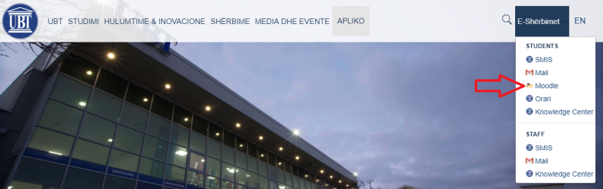
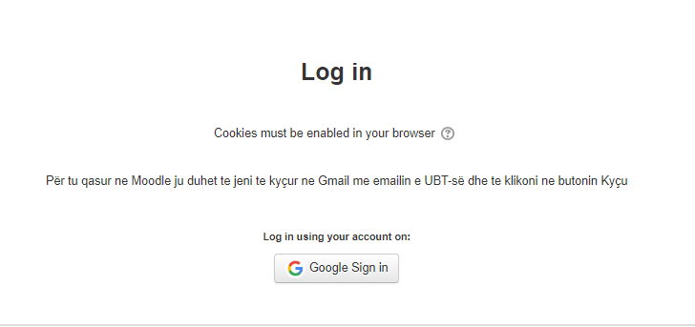
Note: We need to access UBT email in advance at gmail.com so that we can access Moodle.
5. The next step after clicking Google Sign in is that we will be shown the first page of Moodle as the list of faculties, our personal data email name and surname, online bookstores etc.

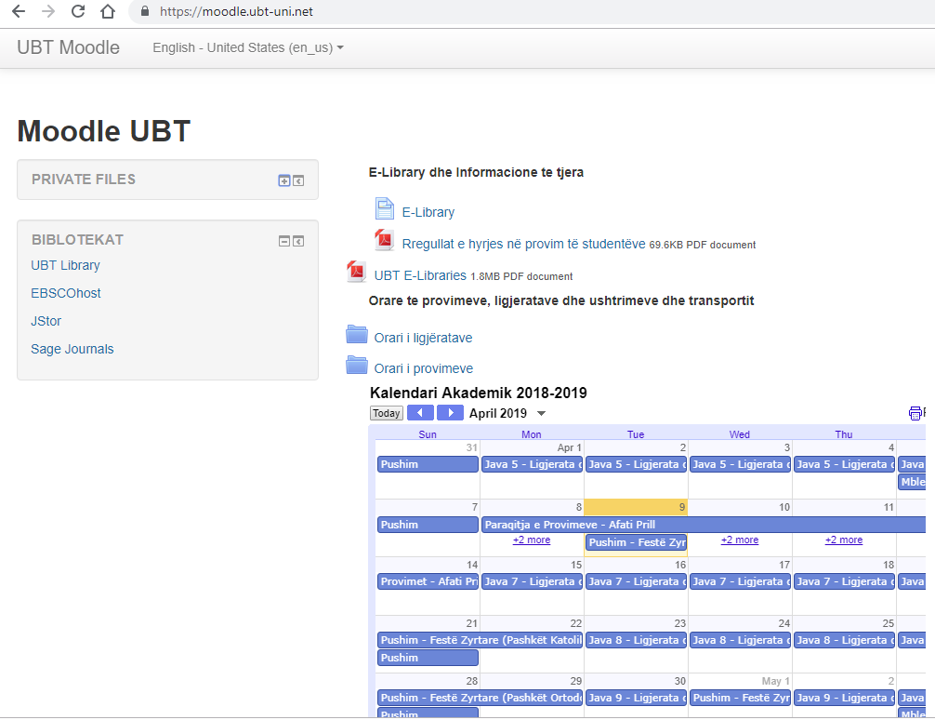
6. After clicking on the faculty to which we belong, we will be shown the division into Bachelor, Master, etc., and after we have chosen this, then the generation or academic year in which we are enrolled, for example, Computer Science, Bachelor, will appear. , Generation 2018/2019 semester II and list of subjects with relevant lecturers.
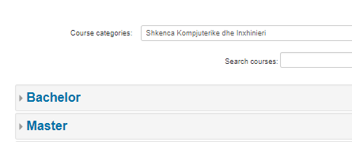
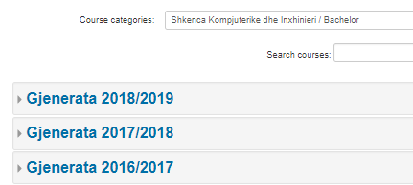

7. After we choose the semester, the subjects of that faculty / semester shall be displayed
8. In order to enter the subject depending on the role we have, for example as a student, we need enrollment key which the lecturer made public in front of the students during the lectures and enables them access to the system, or if you are academic staff, etc. another role from the student then you have to send the email to the faculty and then the IT gives you access to it.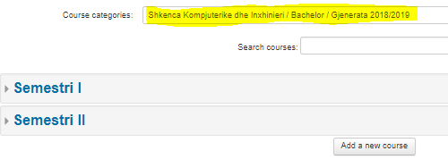
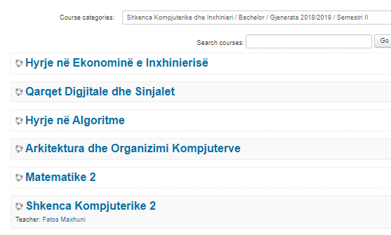
To set in Moodle the graduation process
9. The organization of the subjects is done in the teaching week, e.g. a semester has 12 weeks and for each week materials, assignments, etc. are posted in this system. In this regard, students shall fulfill their required activities and tasks by downloading and sending their assignments in case of course research, etc.
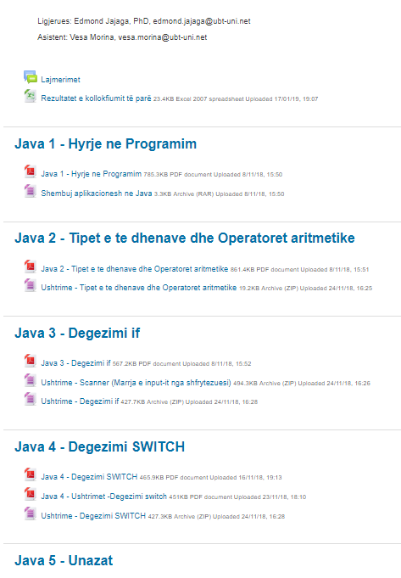
UBT also has a Student Data Management System (SMIS), through which exams can be taken and a distance grading is generated, connection to the system is made through the official UBT website.
For you locked in SMIS follow the steps below
1. Log in to the UBT website: www.ubt-uni.net
2. Click on SMIS as shown in Figure 1.

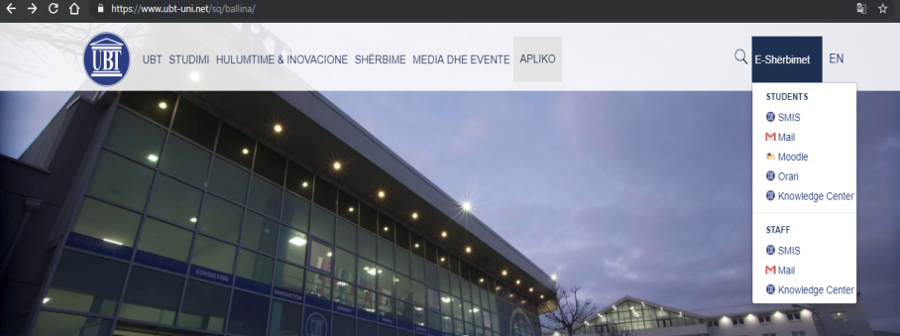
Fig 1
3. On the next page, press the "Sign in / Key (by Google)" button, Figure 2.
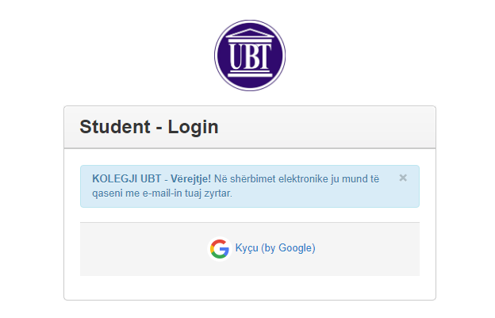
Fig 2

4. Access to SMIS is done only through the official UBT email, see figure 3 and fig 4
Fig3
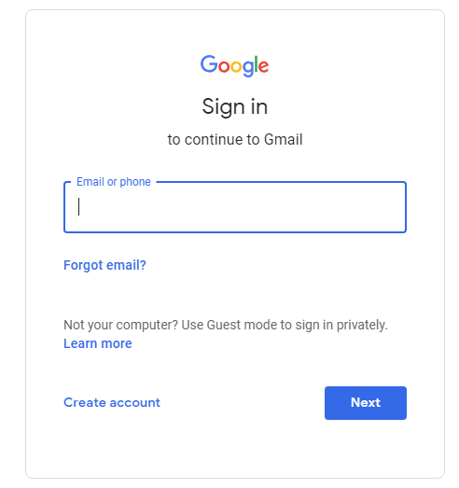
Fig 4
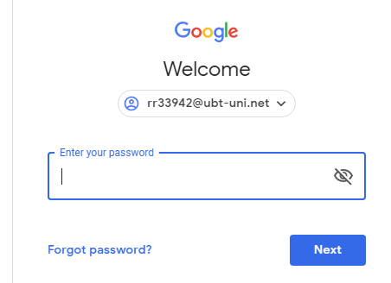
After logging in to SMIS, press the publish submit exams, and here you can take the exams.
