Dear students,
UBT has been founded on 19th of October 2004, after being licensing from the Ministry of Education, Science and Technology. UBT was established as a result of a successful work of the Institute for Enterprise Management and Engineering - IEME, which now operates under UBT.
UBT is a modern institution of higher education, which has been consistently increasing the number of students, professors and administrative staff on annual basis. As a matter of fact, the high scale of institutional organization and consolidation provides excellent opportunity for bearing quality, modern studies and in line with the development trends of higher education in developed countries.
Due to the fact, organization and studies in UBT differs from the academic structure and the teaching mode from other universities that operate today in Kosovo, we consider it necessary to outline and pay attention to this handbook for easier orientation and management of the situations and requirements of students in time and quality. Nevertheless the beginnings of an institution's work can be followed by difficulties and obstacles of various natures. As a result this may lead to it may happen that the level of information and services is not of the desired quality.
Indeed to meet your demands in a qualitative and cultured manner, we ask you to pay attention to the following instructions that derive from this manual.
Thank you in advance for your support and cooperation!
UBT Team

1. WHICH IS THE ACADEMIC STUDY STRUCTURE?
The University offers two-tier study programs according to ISCED:
a. Basic studies - bachelor and master
- Basic studies represent the first stage (third level) of tertiary education, which takes place in two cycles (bachelor and master) and does not directly lead to a qualification for advanced (advanced).
- Advanced (advanced) studies represent the second stage (third level) of tertiary education, which leads to a qualification for advanced (advanced) research.
- Studies in the first stage of the third level (level 6) are carried out mainly in English and in Albanian.

2. WHICH IS THE STRUCTURE OF STUDY PROGRAMS?
- Due to the significant importance of this study program, it is carried out a multifaceted recognition and assuring of the conveyance of knowledge at the university level. Consequently, programs are harmonized and standardized, both by content and by the number of credits per semester in the relevant subject or field.
- The study programs leading to the diploma / certificate in the faculty and the respective profile are modular, expressed through the collection of credits under the European Credit Transfer System (ECTS) and the American System HRS.
- The content of this program content is established and drafted within the subject curricula of the faculty and the respective management. (Notice: see subject curricula by faculties and respective directions).
- Basic subjects (bachelor), for six semesters, are primarily divided into:
- general pre-core subjects;
- core/essential subject’s mandatory for all students;
- the main mandatory subjects for the chosen course in which the student (major) and
- elective subjects, which the student can choose from different fields (elective).
- Each subject, according to the syllabus, is planned to be developed in relevance with the modules in the respective semesters and has a certain number of classes divided per week. The semester usually begins on October 1 of the academic year and lasts 16 weeks of regular work. (Notice: see Regulation on the organization of the teaching process).
- The number of classes for the subject is converted into a number of credits by two systems, the European and American systems.
- To gain a bachelor's degree, you need at least 124 hours in respect to the American system (HRS) or 180 credits according to the European system (ECTS). In this number of credits are also calculated credits obtained from seminars, projects and diploma work or thesis.
- In order to gain a Master's Degree in Master's Degree, the curriculum must at least be equivalent to 300 ECTS credits, including the credits earned from basic bachelor programs.
- To earn a six (8) doctorate degree, the curriculum must at least have the equivalent of 480 ECTS credits, including credits earned from level 7 studies.
- It is a minimum requirement that, for all qualifications in bachelor studies, 1/3 of total credits be earned from UBT studies.

3. WHICH ARE THE RIGHT STEPS FOR A SUCCESSFUL IN LEGISLATION?
Before starting the lectures, it is necessary to;
- Send all the valid documents required by the competition to fill out your personal file and other administrative and financial services to prepare the study contract;
- Carefully read the regulations of the university, announced on the ground floor of the institution;
- Check and sign the study contract with the university;
- Search for in-depth information the Student Service Office for the calendar year of the academic year, including official holidays.
- Ask the Student Service Office for the lesson schedule and determine which learning rooms will develop the learning process;
- Receive the necessary information for the respective semester subjects, at the Student Service Office or in the respective department responsible for advertising;
- Provide and assure the necessary materials for teaching (textbooks, dispensaries, complementary literature, internet access, etc.) according to relevant subjects and in collaboration with the University Library;
- Check the results of the exams and verify with the Student Service Office, the fulfillment of the conditions to continue the studies in the following academic year (non-start students).

The beginning of lectures;
- The lectures are held by the course professor, who also leads the respective subject, in close cooperation with the assistant;
- Lectures last for 45 minutes. A lecture, usually, takes place within two hours of learning, that is, takes place within 90 minutes and then, if the lesson has 4 hours of instruction, it follows a break of 30 minutes and continues with the other two hours of total 90 minutes;
- The professors are required to provide an explanation and closely elaborate the course program, including those elements such as; purpose, objectives, main content, reference literature and assessment method;
- The students enjoy the right to ask the teacher for clarification of the assessment method, the number and types of examinations, the criteria and the method of evaluation, and the criteria and the way of obtaining credits for each subject of the semester;
- Ask the teacher for clarification by arranging certain consultations;

During the learning process;
- Take an active part in the lectures and become part of the process;
- Ask questions about things that are not clear and ask for clarification from the subject teacher;
- By your willingness and commitment to study hard, you will force the teacher to put a lot of efforts to maximize the entire elements required for a teaching process;
- It is not necessary to pay much attention and spend much time on formal matters, but seek, insist, and dedicate yourself to the content and quality of your studies;
- Ask the Student Service Office to meet the hygienic-sanitary conditions, technical and didactic conditions in the classrooms where the lectures are held and in the premises where you are taught, if they are not at the proper level.
- Take brief notes during the lectures and evaluate in a reasoned and objective manner each teacher's and assistant's work;
- Evaluate your ratings in the special box at the reception and we guarantee you anonymity of your assessment.
- An objective assessment not only for teachers, but also for all other UBT services, will help us take the necessary measures to improve the overall quality of our services.
- It is of crucial importance to keep your lectures right, because your attendance at the lectures increases the ability and quality of the studies, but even though your presence in the lectures will be assessed by the teacher in the final grade of the relevant subject at a certain percentage for which he should notify you at the beginning of the lecture;
- The teacher will keep notes of regarding the of student attendance in lectures and if the student is absent in 25 percent of the lectures, he risks losing the status of the regular student;
- In cases of whatsoever problems and obstacles concerned with learning, contact to the coordinator of the respective program, the names of each of them will be posted on the notice board. If he is not capable of providing a solution to the problem please, ask for a meeting with the President of the University or with the person he authorizes to cope with the respective concerning issue.

WHICH ARE THE METHODS OF CARYING OUT THE EVALUATION SYSTEM?
- The scale of student achievement, which comes as a result of evaluation, is quantified with numbers or marks comprehensible and equivalent to the degree of student achievement gained.
- The decision regarding the degree of student achievement and assessment is made by the professor of respective subject independently and in compliance with the criteria and professional evaluation principles.
- The general criteria for the final evaluation, with the exception of the course curriculum, are:
- Regular participation in lectures
- Seminar works;
- Mid-term Exams;
- Results achieved in the final Exam;
- For specific courses and subjects, the subject professor, in accordance with the dean of the faculty concerned, applies special criteria for student assessment, which should be made transparent to the students before the beginning of the learning process.
- The assessment, aims to reveal and determine the most accurate degree of student achievement. It is primarily written in percentage, which is then converted in the equivalent to the letter indicated in the corresponding letter.
- Each grade should be equivalent to the standards of achievement as outlined in the table below, in relevance with the European Academic Assessment System.
Grade | Letter | % | Description
10  9  8  7  6  5*  5 | A  B  C  D  E  F  F | 90.00-100  80.00-89.99  70.00-79.99  60.00-69.99  50.00-59.99  30.00-49.99  0.00-30.00 | Excellent – proficient knowledge, only with some minor mistakes  Very good –beyond the medium standards, but with some mistakes  good – there have been achieved good results, but the general performance still needs improvement  satisfactory- good, with many mistakes  adequate – the results meet the minimal requirements  poor- it’s required extra effort from the student to earn the minimal credits  poor – the student is required to put on a lot o efforts to earn the minimal credits

5. HOW IT IS REALIZED THE PREPARATION AND OVERALL ADMINISTRATION OF THE EXAM?
- Since the beginning of the academic year, the course professor decides on the types of measuring instruments and the assessment of the degree of student achievement in the subject matter.
- The course professor informs the students about the types of assessment that are applied to measure the degree of student achievement in the subject as well as the types of examinations.
- The course professor is obliged during the semester to evaluate the student's knowledge of the given teaching units and to follow his / her progress in the studies. The teacher is obliged to carry out the whole range of all professional and academic measures to help the student achieve the maximum possible number of studies when there is a will of the student.
- The course professor is obliged to lead students to get to know about the percentage of the calculated percentage of each semester exam, within the general grade of the subject.
- The final exam is organized to assess the student's achievement rate in all subject areas at the end of the respective semester.
- The final exam is organized in three regular terms:
- February term;
- June term and
- September term;
- In case of failure in the first term the student has the opportunity to be tested in two other terms. The student must be given sufficient time to complete the exam, at least two weeks from the date of completion of the module or from the date of announcement of the results.
- The student is not permitted to continue the lectures and the teaching process in the next semester in those subjects that ask for maximal achievements of previous semester subjects. Also, the student can take the exam in all those subjects of the respective level of education but are not subject to the contents of the other subjects.
- Basically, the final exam score should be no more than 50% of the student's overall grade, except for specific subjects and when the University Senate decides takes specific measures.
Procedures
- Examination deadline starts at least 10 days before the exam deadline and ends 3 days from the commencement date of the exams.
- The UBT authorities are obliged to announce the exam schedule for the entire academic year at the beginning of each academic year in the notice board. For the term of the exam, students are also informed via e-mail.
- In case of changing the exam schedule, this ought to be done with the permission of the rector or his authorized person, only in special cases. As far as this issue is concerned, students must be informed at least 5 days prior to the exam date announced in the table above.
- The student is obliged to submit the exams online through the electronic system (SMIS)
- The student who did not manage to submit the exam within the prescribed deadline, advertised on the notice board, with which students are also informed by electronic mail, cannot take the exam in the subject and within the respective deadline.
- To submit an examination, he / she must have preliminarily fulfilled the financial obligations to UBT in respect to the signed contract for study.
- The course professor is obliged to prepare a test (examination assignments) for each exam period, which provides a real and unpredictable assessment of student knowledge. This is the reason why; the tests must not be identical to any of the tests of the previous terms.
- The professor bears responsibility and is obliged to obtain at least three days prior to the examination, at the relevant UBT service, the nominal list of the students presented for the exam (exam record), which he / she must complete and return with the exam material in the relevant UBT service, upon completion of the exam.
- In cases when the course professor is facing difficulties or is unable to well-administer the exam (this is mainly for external professors), he is obliged to send the test (exam duties) to the responsible person at least three days before the exam date UBT. Due to the fact, UBT can make the necessary technical preparation of the exam and its good administration.

Administration
- UBT is obliged to create physical and psychological facilities for the examination process, so that the student's knowledge can be expressed realistically, without hampering, without interruption and inadmissible aid, on the one hand, and that knowledge can be assessed realistically by the professor, on the other hand.
- The UBT's administration, taking into account the number of students submitted for the exam, makes multiplication and strict secrecy of the test secrecy.
- In the absence of the professor of the subject, on the day of the exam, the relevant UBT service is obliged to professionally administer the exam process until the exam materials are passed to the respective professor, before for his obligations for the return report of the exam results held.
- In the absence of the respective professor or the subject assistant, the exam administration is made by the person appointed by the Rector (University President) or Vice Rector for Academic Affairs. In the absence of a rector (presidential) or a Vice-Rector for academic matters, the Examiner is appointed by the Secretary of the University.
- The test administrator has all the powers of exam administration, keeping the evidence (record) of the student's participation in the exam from the list of students who have submitted the exam, placement of students in such a way as to avoid copying between prohibiting the use of materials and teaching materials related to the subject and the examination and prohibition of mobile phones.
- When the substitute professor cannot appear to participate in the exam, the test administrator is obliged to pass on the record of taking the exam along with the tests.
- A student, who delays the exam, at the time, may be allowed to pass the exam only with the consent of the teacher or test administrator.
- The exam lasts according to the time given by the subject professor, but not more than 120 minutes or two full hours.

Results
- The professor of the respective subject is obliged to submit the return report and the test together with the results of the exam, expressed in percentages, at the relevant UBT service at least 14 days from the date of the exam.
- If the professor has not been present at the exam on the day of the exam, he / she is obliged to submit the return report and the tests together with the exam results to the respective service, at least 14 days from the date of the exam materials of UBT.
- In addition to the respective exam materials, the professor is obliged to submit the record of the exam results to the person in charge of the UBT who is archived in the UBT archive, and the test results are posted on the advertisement table and the same are registered in each student's computer files separately.
- The student has the right to have a look at his or her test in the presence of a subject professor, assistant or officer responsible for student affairs. The student is not entitled to have the original test but only his copy available.
- If the student is not satisfied with the results, he / she has the right to object to the subject professor and, in the worst case, to the Dean of the Faculty or the Learning Coordinator.
- In cases when the student is dissatisfied with the assessment of the exam, he or she may, within 48 hours after the announcement of the result, request a commission examination.
- The Dean of the faculty or Rector is obliged within 48 hours to form the respective commission for re-examining the student.
- A student who is not able to pass the exam in the relevant subject in the first term of the exam, he / she may test for the second time in the regular exam period. If the student couldn’t manage to pass the exam even after the second attempt he / she is enjoys the right to ask for the commission to be examined in the third term.

6. WHICH IS THE CORE FUNCTION OF THE STUDENT SERVICE OFFICE?

6.1 Which is the purpose of getting into touch with the Student Service Office?
This office provides you with the following services;

  - Submission of the application for registration;
  - Submission of documentation for filling in the personal file;
  - Signing the contract for study;
  - Submission of a request for receipt of a certificate as a regular student of UBT;
  - Taking authorization that you are a regular student of UBT;
  - To provide information regarding the lesson schedule;
  - To provide information on the eventual change of class schedule;
  - To provide information concerned with the exam schedule;
  - To provide information on eventual change of exam schedule;
  - To take the respective measures for enrolling in the exam;
  - To provide information on the results of the exams;
  - To tackle the process related to the submission of the application for obtaining the grade transcript;
  - To cope with the harmonization of the number of loans by subject and conversion of grades in percentages and vice versa;
  - To give feedback to those who ask for obtaining a grades transcript;
  - To scrutinize the submission of various requirements foreseen in the study contract;
  - To help students to have access at their personal files.

6.2 How can you have access to it?

- Directly to the Student Service Office, where the relevant form is obtained, fill in and submit briefly the purpose of your application, or
- By means of Internet, relying on the nature of the service and emergency.

6.3 Which time can you have access to it?

- You can appear in the administration officials at any time within working hours, from 08:30 to 17:00;
- For requests requiring an administrative response, you can receive the answer within the day, while for claims requiring professional response or decision by relevant UBT bodies, the application must be submitted at least 48 hours before the time you need the answer or the relevant document.

6.4 Which is the purpose of getting into contact with the Information and Communication Office?

You may contact this for the following purposes;
- To obtain general information about UBT;
- It provides information about what UBT offers at the level of higher education in Kosovo;
- The contents of the UBT web site and the way of access and communication in it;
- Brochures, leaflets, posters, catalogs and publications of administrative and academic documents;
- Publish your works on the UBT web site.

6.5 WHICH ARE THE CORE FUNCTIONS OF THE DEAN OF THE FACULTY

He has the following functions and responsibilities;
- To give explanations for the academic system;
- To give explanations for the curriculum of the relevant study program;
- To give explanations for orientation in studies in the respective program;
- To cope with problems regarding the attendance in studies;
- To cope with and tackle the obstacles in the learning process caused by various factors;
- Problems regarding the harmonization of lesson and exams;
- To Submit and scrutinize random requests and complaints regarding the respect of academic regulations in the studies.

6.6. WHICH ARE THE CORE FUNCTIONS OF THE PRESIDENT/RECTOR OF THE UNIVESITY?

The UBT President of Rector has the following functions and responsibilities;
- In very specific cases for study conditions that are not advertised in the competition;
- For everything that has to do with the learning process and you cannot choose with the program dean;
- To respect the study plan and program;
- To provide an orientation and set goals for the academic structure of the study;
- To initiate and carry out collaborations regarding studies with UBT international partners;
- To take measures concerned with improvement of the overall quality of the studies.

6.7 WHICH ARE THE CORE FUNCTIONS OF THE GENERAL SECRETARY

The General Secretary has the following functions and responsibilities;
- Students' rights set forth by law and other UBT regulations;
- To tackle and closely elaborate UBT and student obligations during UBT studies;
- To make a legal review of the study contract and obligations arising from both parties;
- To carry out legal interpretation of study conditions for relevant student categories;
- To tackle the submitted requests and complaints for the administration service and staff in general;
- To analyze the submitted various requirements for improving administrative services, where the administration cannot provide services without the Secretary or President's decision, as well as on various issues related to the overall quality improvement of administrative, technical services and professional.

6.8. WHICH IS THE FUNCTION OF THE LIBRARY OFFICER?

The library officer has the following functions and responsibilities;
- To provide books and dispensaries of relevant subjects, as well as other supplementary materials for study;
- To fulfill the Photocopying services;
- To provide the suitable facilities for reading and studying;
- To manage the reading process and carry out periodical research.

6.9 WHICH ARE THE FUNCTIONS OF TECHNOLOGY OFFICER?

The technology officer has the following functions and responsibilities;
- To provide technical facilities in the IT lab;
- To providing access to school research programs;
- To manage the well-functioning of Quality Internet Services for School Programs and Scientific Research;
- To notice and repair any eventual defect of electronic or mechanical equipment of UBT equipment;
- To avoid the disruption of the Internet network or any computer device;
- To provide professional guidance on how to use the computer and the way and time of using IT capacities;
- To provide support for access to and use of official UBT email;
- To provide support for access to SMIS student management system;
- To provide support for the use of the E-Learning MOODLE system.

6.10 WHICH IS THE FUNCTION OF THE FINANCIAL OFFICIAL?

The UBT Financial Official has the following functions and responsibilities;

- He is responsible for providing information on payment terms and order
- Contracts of study;
- Eventual clarification of payments;
- Certification of payments;

6.10. WHY SHOULD YOU REFER TO CAREER AND INTERNSHIP CENTRE?

Career and Internship Center at UBT, aims to orient and advise students to link the academic process to the labor market and experience through internships. The Center offers professional services to students since the first day of studies at UBT, providing vocational training and counseling in raising their skills, as well as additional services such as CV preparation, motivation letters, interviewing and follow up to their employment.

More specifically, CIC offers the following services:
- Information for students;
- Orientation and Professional Training;
- Coordinates student internships;
- Information on international programs;
- Intercourse with the group of former students (Alumni)
- Various certifications;

Manual for access to Moodle
1. Check out the UBT website www.ubt-uni.net
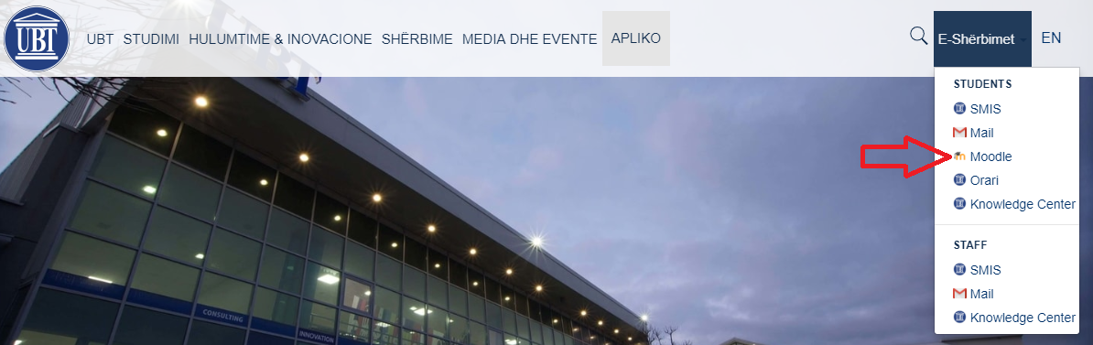

2. Click on the section of E-services - Moodle
3.The next Moodle page opens and then clicks Google Sign IN

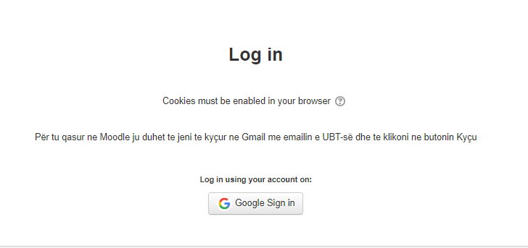
Note: We must first access UBT email at gmail.com so that we can access Moodle.

5. The next step after clicking on Google Sign in is that we will see Moodle's first page as the list of faculties, our personal e-mail name and surname, online bookmarks etc.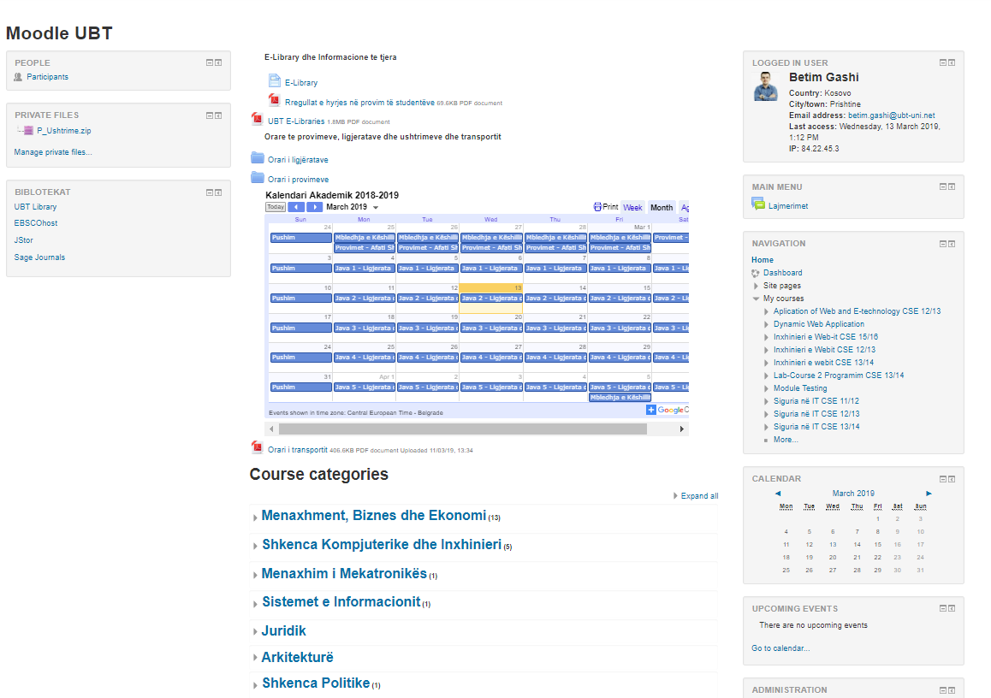
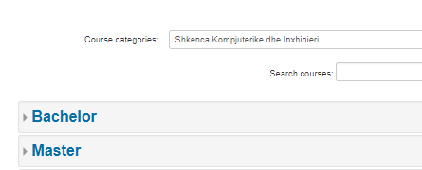
6. When we click on the faculty we belong to, we will see the division in Bachelor, Master etc. and after choosing this then will be shown the generation or academic year in which we registered for example Computer Science, Bachelor, The 2018/2019 semester II and the list of subjects with the respective professors.
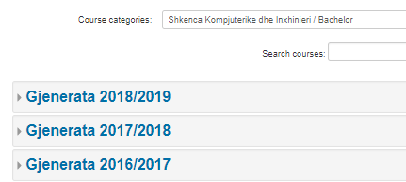

7. Once we choose the semester there is displayed the subjects of that faculty / semester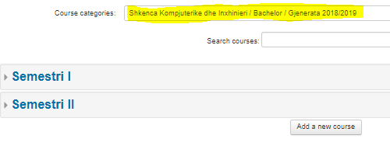
8. To enter the subject depending on the role we have for example as a student, we need an enrollment key which the lecturer gives to the students during the lectures and enables them to enter the site, or if they are academic staff etc. ie another role from the student then you should send the email faculty and
then IT gives you access to it.
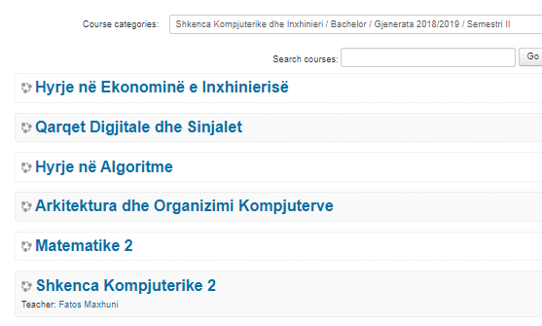
9.Organization of subjects takes place in a week of teaching ie one semester is 12 weeks and for each week there are posted materials, assignments etc where students have interaction by reading, downloading and sending their tasks in case of research etc.
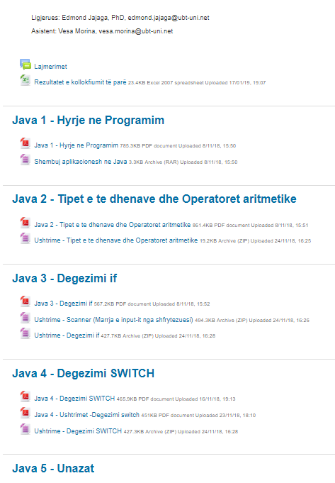

The Manual for exam presentation (SMIS)

1. Log in to the UBT website: www.ubt-uni.net
2. Click SMIS as in Figure 1.
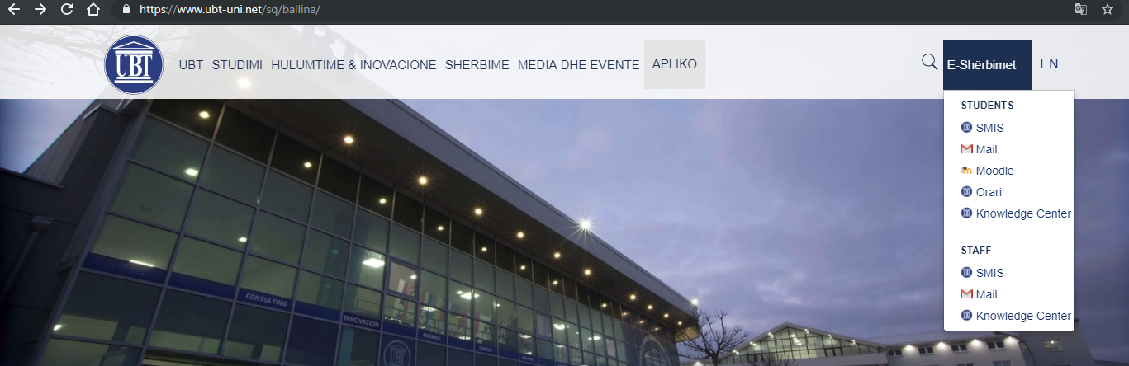
Fig 1

3. Once the next page appears click on "Sign in (by Google)", Figure 2.
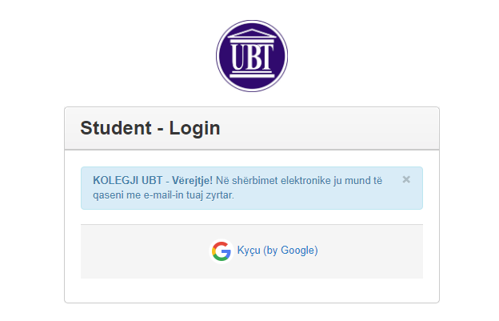
Fig 2

4. Connection to SMIS is done only via the UBT official e-mail / account, figure 3, 4.
Fig3
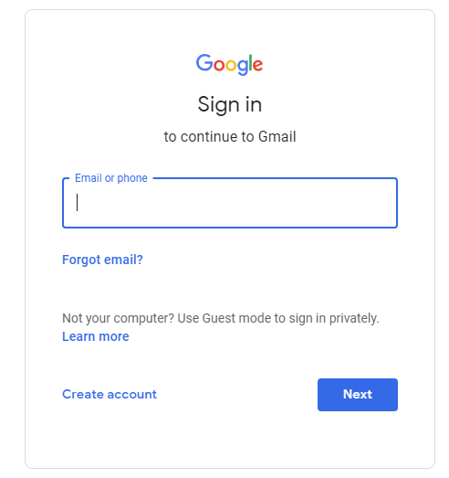
Fig 4
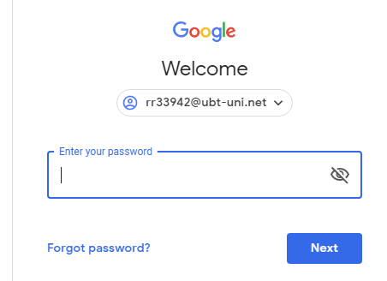
After you log into SMIS click on the Exit Exams section (Paraqit Provimet)
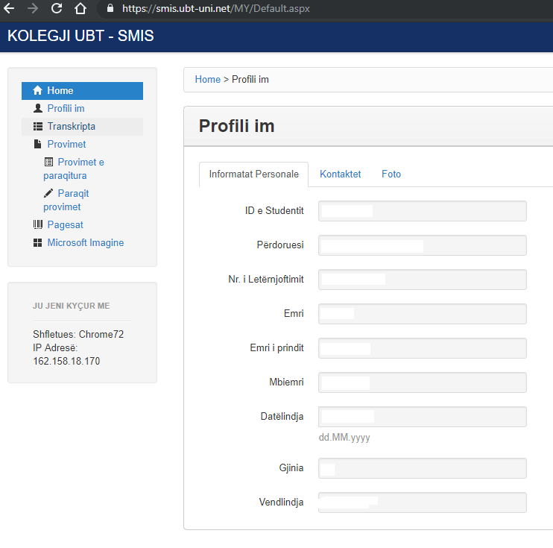

Infrastructure

Description of UBT facility - Pristina

The ground floor - 0
Number of office - class | Name
A001 | Classroom
A002 | Amfiteatër
A003 | StorehouseA002
A004 | StorehouseA007
A005 | Dera Afër A008
A009 | TOILETS door

Floor -1
Number of office - class | Name
A101 | Training room
A102 | Career Center
A104 | IT Office
A105 | Classroom
A106 | Media Group
A107 | Human resource
A108 | Classroom
A109 | UBT STATS
A110 | Amphitheater
A111 | Secretary's Office & Logistics
A112 | Photocopy
A113 | Men’s toilets
A114 | Women’s toilets
A115 | Meeting room
A116 | Office for Student Affairs

Floor - 2
Number of office - class | Name
A201 | Technical space
A202 | Classroom
A203 | Office
A204 | Office
A205 | Classroom
A206 | Depo
A207 | Women’s toilets
A208 | Emergency Stairs 1
A209 | Women’s toilets
A210 | Classroom
A211
A212 | Office
A213 | Office
A214 | Office
A215 | Office
A216 | Men’s toilets
A217 | Emergency Stairs 2
A218 | Men’s toilets

Kati 3
Number of office - class | Name
A301 | Classroom
A302 | Office
A303 | Office
A304 | Classroom
A305 | Women’s toilets
A306 | Emergency Stairs 1
A307 | Women's toilets
A308 | Klasë
A309 | Classroom
A310 | Office
A311 | Classroom
A312 | Archive
A313 | Men’s toilets
A314 | Emergency Stairs 2
A315 | Men’s toilets

Kati 4
Number of office - class | Name
A401 | Finance Office
A402 | Rector's Office
A403 | Rector's Office
A404 | Server Room
A405 | Men’s toilets
A406 | Office
A407 | Office
A408 | Office
A409
A410 | Women's toilets

UBT Innovative Campuses _Lipjan

Building - E
Number of office - class | Name
E001 | Classroom
E002 | Classroom
E003 | Classroom
E004 | Classroom
E005 | Classroom
E006 | Classroom
E007 | Reception desk
E008 | Office
E009 | Server Room
E010 | Men’s toilets
E011 | TOILETS
E012 | Women's toilets
E013 | Office
E014 | Classroom
E015 | Office
E016 | Classroom
E017 | Classroom
E018 | Amphitheater
E019 | Amphitheater
E020 | Classroom
E021 | Classroom
E022 | Classroom
E023 | Laboratory
E024 | -
E025 | Classroom
E026 | -

Building - F

Number of office - class | Name
F001
F002 | Classroom
F003 | Classroom
F004 | Classroom
F005 | Classroom
F006 | Classroom
F007 | Office
F008 | Office
F009 | Women's toilets
F010 | Toilets
F011 | Classroom
F012
F013
F014 | Classroom
F015 | Classroom
F101 | Server Room
F102
F103 | Men’s toilets
F104 | Women’s toilets
F105 | Classroom
F106 | Classroom
F107 | Classroom
F108 | Office
F109 | Office
F110 | Amphitheater
F111 | Classroom

Objekti - G
Numri i klasës -zyrës | Emri
G001 | Classroom
G002 | Toilet for Staff
G003 | Men’s toilets
G004 | Women's toilets
G005 | Toilets
G006
G007 | Classroom
G008 | Classroom
G009 | Classroom
G010 | Classroom
G011 | Classroom
G012 | Classroom
G013 | Classroom
G014 | Classroom
G101 | Classroom
G102 | storehouse
G103 | Classroom
G104 | Classroom
G105 | Classroom
G106 | Classroom
G107 | Classroom
G108 | Laborator
G109 | Classroom
G110 | Classroom
G111 | Classroom
G112 | Women's toilets
G113 | TOILETS për Meshkuj
G201 | Classroom
G202 | Depo
G203 | Classroom
G204 | Classroom
G205 | Classroom
G206 | Classroom
G207 | Classroom
G208 | Classroom
G209 | Classroom
G210
G211 | Classroom
G212 | Classroom
G213 | Classroom
G214 | Classroom
G215 | Classroom
G216 | Classroom
G217 | Classroom
G218 | Women's toilets
G219 | TOILETS për Meshkuj
G301 | Dhomë Serveri
G302 | Depo
G303 | Classroom
G304 | Depo
G305 | Classroom
G306 | Zyrë
G307 | Classroom
G308 | Classroom
G309
G310 | Classroom
G311
G312 | Classroom
G313
G314 | Women's toilets
G315 | TOILETS për Meshkuj

UBT – Ferizaj

Kati Përdhese - 0
Numri i klasës -zyrës | Emri
L001 | Klasë
L002 | Klasë
L003 | Klasë
L004 | Klasë

Kati - 1
Numri i klasës -zyrës | Emri
L101 | Zyrë
L102 | TOILETS
L103 | Zyrë

Kati - 2
Numri i klasës -zyrës | Emri
L201 | Classroom
L202
L203 | TOILETS
L204 | TOILETS
Kati - 3
Numri i klasës -zyrës | Emri
L301 | Classroom
L302
L303
L304 | TOILETS
Kati - 4
Numri i klasës -zyrës | Emri
L401 | Klasë
L402 | Biblioteka
L403 | Klasë
L404
L405 | Klasë
L406 | Klasë
L407
L408 | Klasë
L409 | Klasë
Kati - 5
Numri i klasës -zyrës | Emri
L501 | Classroom
L502 | TOILETS
L505 | TOILETS
L601 | Classroom

UBT Prizren

Kati Përdhese - 0
Numri i klasës -zyrës | Emri
N001 | Zyrë
N002 | Biblioteka
N003 | Klasë
N004 | Klasë
N005 | Klasë
N006 | Depo
N007 | TOILETS
N008 | TOILETS
Kati - 1
Numri i klasës -zyrës | Emri
N101 | TOILETS
N102 | TOILETS
N103 | Klasë
N104 | Classroom
N105 | Klasë
Kati 2
Numri i klasës -zyrës | Emri
N201 | Amfiteatër
N202 | Classroom
N203 | Klasë

