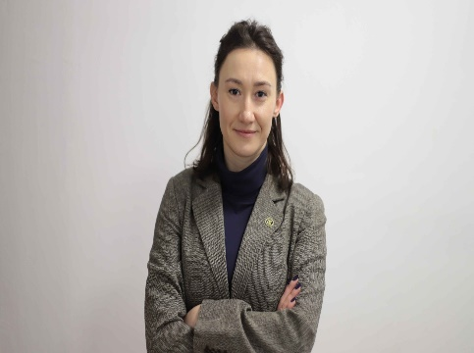

Asst.Prof.Dr. HAJDI XHIXHA

DEAN OF FACULTY OF POLITICAL SCIENCE, University for Business and Technology, Kosovo

An expert of Russian-Albanian relations, with a specific focus on the international relations and security issues. Highly proficient in Russian and Macedonian languages and culture. An expert of Russian policies and influences in the Balkans, in particular in Albania, Kosovo and North Macedonia. An expert of security policies. Dr. Xhixha has earned her PhD in International Relations with the thesis “Albanian-Soviet Relations, 1949 – 1960” from Institute for European Studies, University of Tirana. She has graduated the university-level studies on expert of Russian and Macedonian language and culture at the UT, where she was awarded the certificate “EXCELLENT STUDENT” of University of Tirana in 2008. In the course of her studies, Dr. Xhixha has combined her proficiency in Russian language and culture with the discipline of international relations, diplomacy and security. She is the Responsible person for Political Science BA, Security Studies BA & Public Policy and Management MA programs; CO-CHAIR of the UBT work team for joint project between UBT & CENTRE FOR RESILIENCE AND SUSTAINABLE DEVELOPMENT CAMBRIDGE, Policy Simulation Lab in Kosovo, on topic “Cambridge Policy Boot Camp (CPBC) on Feeding Children Nutritiously for Kosovo and the Coordinator of Joint Master PoSIG – Political Science International Relations and Governance Joint Master between UBT and Salzburg University.

ORCID: https://orcid.org/0000-0003-2584-5109
RESEARCH GATE: (11) Hajdi Xhixha (researchgate.net)
Email: hajdi.xhixha@ubt-uni.net
Address: University for Business and Technology. Rexhep Krasniqi Nr. 56, 10.000 Prishtina, Kosovo

SCIENTIFIC PUBLICATIONS
Scientific Journals
Title of work | Journal’s name | Year / Volume / pages
Testing Okun’s Law: Evidence From the Western Balkan Countries | Sage Open Journals | 2023/volumen 13/Issue 4  https://doi.org/10.1177/21582440231208332
“Socialist reforms for the Albanian government reconstruction: Stalin’s policy in Albania 1947-1949” | Russian State University “Druzhbi narod” PRESS, Moscow, Russia | 2019/ УДК 34(063) ББК 67/ П68/ pp.173-176  ISBN 978-5-209-09354-1
School Book “Мајчин Јазик” | Center BOTEM, Ministry of Education, Sport and Youth in Tirana, Albania | 2019/ Hard Copy, Book of learning of Macedonian Language for the Macedonian Minority in Albania, 3rd Grade
“Poetic geniality of A.S. Pushkin in the tragedy of Boris Godunov”, | The dimensions of alexander s. Pushkin’s work, UT-Press, Tirana, Albania | 2019/Hard Copy/ ISBN: 978-9928-4525-6-6
Summary (abstracts) from Scientific international and national conferences
Title of work | Journal’s name | Year / Volume / pages
“The taleban as a phenomenon of International Relations; strategic views on the level of international security | Book of Procedings, UBT International Conference, ISBN 978-9951-550-47-5 | 2021/  https://knowledgecenter-ubt-uni.net/cgi/viewcontent.cgi?article=3163&context=conference/ pp.386
The force of use against civil aircraft-intruders; International legal aspects | Book of Procedings, UBT International Conference, ISBN 978-9951-550-47-5 | 2021/  https://knowledgecenter-ubt-uni.net/cgi/viewcontent.cgi?article=3163&context=conference/ pp.372
Ideological Security in Soviet Russia and Russian Federation: Similarities and updates | Full Book Conference USBED 2023, Istanbul, Turkey | https://usbed.org/wp-content/uploads/2023/11/Full-Book_-USBED-Conference_-2023.pdf , pp.39
Other Publications
Title of work | Journal’s name | Year / Volume / pages
“Killings of post office boys” – Perihan Magden | Translation from Russian Language | 2014, Publish House “Fan Noli”, Albania

