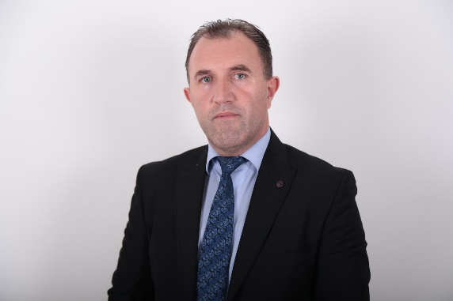
Dr. Sc. Nuredin Lutfiu has over fifteen years of experience in teaching and various responsibilities throughout his career. His professional journey includes the following roles:
Lecturer since 2009 in various private higher education institutions in Kosovo.
Assembly member in the Municipal Assembly of Viti, serving from 2013 to 2021.
Regular lecturer at UBT College in Prishtina from 2020 to the present.
Author of various scientific articles on criminal law.
Nuredin Lutfiu's extensive experience in academic and legislative roles reflects his dedication to education and public service.

PUBLICATIONS
Scientific Journals
Title of work | Journal’s name | Year / Volume / pages
“Gender Equality Issues in Kosovo” | International Journal of Social Sciences “ VISIONE” in Skopje | No. 22/ 2014 (ISSN)
“Divorce Stages and Methods under Kosovo Legislation” | Institute for Legal and Democratic Studies (ISLD) | No.1/2015 (ISSN)
“Issues of International Child Abduction under the Legislation of the Republic of Kosovo” | Publication of the scientific paper from the 9th Scientific Conference held on 08-09 April 2016 in Dubrovnik | ISBN 9788890916373
“The Impact of Precedent in the Legal System of Kosovo” | West East Journal of Social Sciences | ISSN 2168-7315 ( online) USA
Summary (abstracts) from Scientific international and national conferences
Title of work | Journal’s name | Year / Volume / pages
Securing a Claim | University for Business and Technology - UBT, 12th International Conference on Business, Technology and Innovation 2023" UBT International Conference. | 30-31 October 2023, Prishtina, Kosovo

