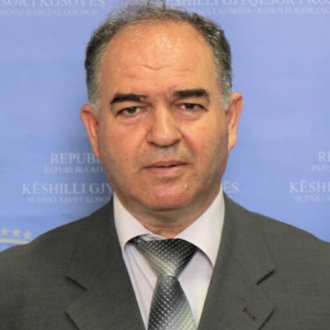
Professor Nehat Idrizi has over 30 years of extensive work experience in roles such as a judge, lecturer, manager, administrator, and trainer at the Justice Academy in Prishtina. He has accumulated 3 years of management experience as the head of the Judicial Council of Kosovo and nearly 2 years as a member. Currently, he holds the position of a judge at the Court of Appeals in Prishtina and is engaged as a professor at UBT College. Holds the title of doctor of legal sciences.
Some of Professor Nehat Idrizi's notable titles include:
- President of the Judicial Council of Kosovo;
- Member of the Electoral Complaints and Appeals Panel (ECAP);
- Secretary of the Education Directorate in Gjilan;
- Head of the Legal and General Services Department at the Public Housing Enterprise.
PUBLICATIONS
Scientific Journals
Title of the paper | Title of the journal | Year / Volum / Page
” Cështjet e barazisë gjinore në Kosovë ” | Revistën ndërkombëtare për shkencat shoqërore “VISIONE” në Shkup | 19-20.09.2014  nr.22/2014 (ISSN)
”Fazat dhe Mënyrat e shkurorëzimit sipas legjislacionit të Kosovës ” | Revistën Regjionale të Shkencave Shoqërore “REFORMA” në Gjilan | 07.03.2015  nr.1/2015 (ISSN)
“Qeshtjet e Rrëmbimit Ndërkombëtar të Fëmijëve sipas Legjislacioni të Republikës së Kosovës” | Publikimi i punimit shkencor i mbajtur në Konferencën e IX (nëntë) shkencore të mbajtur me datën 08-09 Prill 2016 në Dubrovnik | 08-09.04.2016  ISBN 9788890916373
“Ndikimi i Precedentit në Sistemin e së Drejtës në Kosovë” | Publikimi i punimit shkencor në Revisten “ West East Journal of Social Sciences” | 06.12.2017  ISSN 2168-7315(online) SHBA
Summaries (abstracts) from International and National Scientific Conferences
Title of the paper | Title of the journal | Year / Volum / Page
Securing a Claim | University for Business and Technology - UBT, 12th International Conference on Business, Technology and Innovation 2023" UBT International Conference. | 30-31 October 2023, Prishtina, Kosovo

