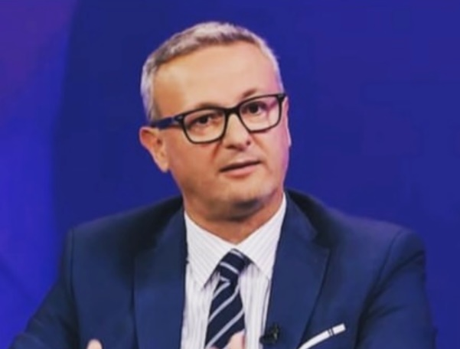

Prof.Assis.Dr. Dritero Arifi

Professor Dritero Arifi is a distinguished faculty member at the esteemed University for Business and Technology (UBT) in Prishtina, where he teaches in the Department of Political Science. He is a two-time recipient of the prestigious WUS-Austria scholarship, and his areas of expertise include security concerns, European foreign policy, diplomacy, and democratisation. Dr Arifi earned his PhD in Political Science from the University of Vienna, and he has also served as an advisor to the Ministry of European Integration of the Republic of Kosovo for more than five years.

ORCID: https://orcid.org/my-orcid?orcid=0000-0002-0523-2412
RESEARCH GATE: https://www.researchgate.net/profile/Dritero-Arifi
Email: dritero.arifi@ubt-uni.net
Address: University for Business and Technology. Rexhep Krasniqi Nr. 56, 10.000 Prishtina, Kosovo

SCIENTIFIC PUBLICATIONS
Scientific Journals
Title of paper research | Journal’s name | Year / Volume / pages
"Kosovo Society: Coexistence, Challenges and Opportunities. An Overview of Social Policy in Serbia and Kosovo" | Brill Publishing House | Vo  2022/Volume 210/pp 224-254
Institutional and non-institutional actors in policy-making processes: a case study | Journal of Governance and Regulation | 2023/ Volume 12/ Nr 2/ pp 147-155
The education situation of the Roma community in Kosovo | Emerald Publishing | 2023 / 1-15
Testing Okun's Law: Evidence from the Western Balkan Countries | SAGE OPEN | 2023/Volume 12/Nr 2/pp 147-155
Summary (abstracts) from Scientific international and national conferences
Title of paper research | Title of paper research | Year / Volume / pages
The Albanian national unification in the Balkans area in the context of Kosovo’s political party programs | Konferencë Ndërkombëtare  Kolegji UBT | 2108
Ethics code of NGOs in Kosovo | Konferencë Ndërkombëtare  Kolegji UBT | 2019
Public diplomacy and the case of Kosovo | Konferencë Ndërkombëtare  Kolegji UBT | 2020
The importance of public participation in building up democracies in former Yugoslav states. Case study: Kosovo and Croatia | Konferencë Ndërkombëtare  Kolegji UBT | 2020
The gap between the legal framework and social order in addressing property rights for Kosovo women | Konferencë Ndërkombëtare  Kolegji UBT | 2021
The level of student participation in decision-making processes in Kosovo Universities: a comparative study between the University of Prishtina and the University of Business and Technology | Konferencë Ndërkombëtare  Kolegji UBT | 2021
The trade war between the U.S. and China and its impact on the E.U. | Konferencë Ndërkombëtare  Kolegji UBT | 2022

