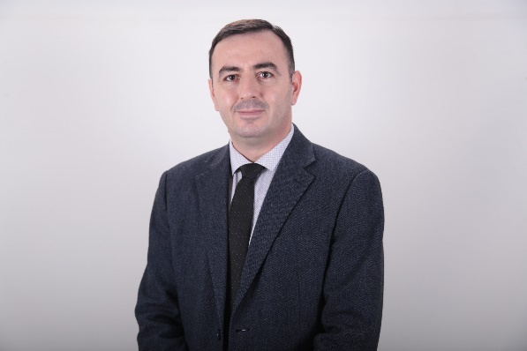
Dr. Sc. Elmi Kelmendi has over 15 year experience in teaching (since 2009) in legal judicial area,
professional experience as graduate in law of over nineteen years (since 2005) in Public Institutions, Institutions of higher education and in private companies.
Professor Kelmendi has thus far performed various expertise tasks in various areas, especially in
that of higher education and in vocations education, in drafting legal acts starting from concept documents, laws, administrative instructions, statutes and various regulations. Professor Kelmendi
has participated in many international seminaries, local and international trainings, participant in
various local and international conferences, etc.
In addition, Professor Kelmendi has been a part of an academic mobility project in 2022 within ERASMUS+ project (KA107 Staff Mobility for Teaching Academic Year 2021/2022), in Bialystok
University, Faculty of Law in Poland, where he delivered a series of lectures from the area of Criminology, Organized Crime and in International Criminal Law. Some of the selected professional items of professor Kelmendi are as follows:
– External legal expert in drafting legal acts in project ALLED2 (project that is co-financed by European Union and the Austrian Development Agency (ADA) – provision of legal expertise in
drafting Administrative Instruction on the formula of financing of system of Vocational Education
and Training in Kosovo; Support with legal expertise for National Qualifications Authority in drafting the concept/document of policies and legal framework for Quality Assurance in Vocational Education and Training (VET); Provision of legal expertise for National Qualifications Authority in drafting the Work Regulation of Managing Council of NQA.
- Expert in Quality Assurance in National Qualifications Authority, external expert in legal matters
in drafting the regulation for systematization of work positions in National Authority of Qualifications;
– External experts in legal matter in DVV International (Internationale Zusammenarbeit des Deutschen Volkshochschul-Verbandes) in drafting the regulations for application of Institutions of Education and Vocational Training in the process of validation of qualifications in the National
Framework of Qualifications;
– External experts in legal matters in European Center for Minority issues in Kosovo (ECMI Kosovo) for professional evaluation of concept document, etc.

PUBLICATIONS

Title of paper | Journal’s name | Year / Volume / pages
Necessity for criminal justice reform in Kosovo | UBT Conference 2020 | 2020
Confiscation of assets with criminal origin as a form of fight against organized crime in Kosovo | UBT Conference 2021 | 2021
Lack of professionalism in justice system as a source of criminality | UBT Conference 2023 | 2023

